**React ChartJs label Info**

1. We can make the labels inside the pie chart, And to make it we have to follow the steps of the ChartJS and than follow the following steps
2. First install the package by writing the following line in terminal

**npm install chartjs-plugin-datalabels --save**

1. And than import the following package where you had used the <PieChart>, <BarChart>, <LineChart> alias

**import {Chart} from ‘chart.js’;**

**import ChartDataLabels from ‘chartjs-plugin-datalabels’;**

1. And than add the following statements in the function where you had used the <PieChart>, <BarChart>, <LineChart> alias**(DO USE THE FOLLOWING STATEMENT ONLY ONE TIME IN THE PROJECT AND IT WILL BE IMPLIMENTED IN THE WHOLE PROJECT)**
2. 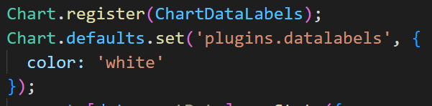
3. By